5.1.1 } Leap year checker
Algorithm :--
- Start
- Read the input year.
- Check if the year is divisible by 4 and not divisible by 100 and the year is not divisible by 400.
- If the condition is true, Display "Leap year".
- Else Display "Not a leap year".
- Stop

Code :--
year = int(input())
if(year %4 == 0 and year % 100 != 0) and (year % 400 != 0) :
print("Leap year")
else :
print("Not a leap year")

Flow chart :--

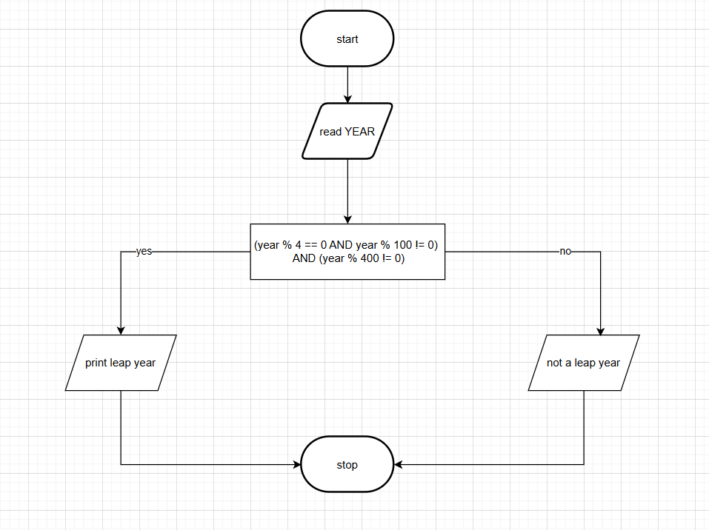

Codetantra :--

